**MinIO Connector**

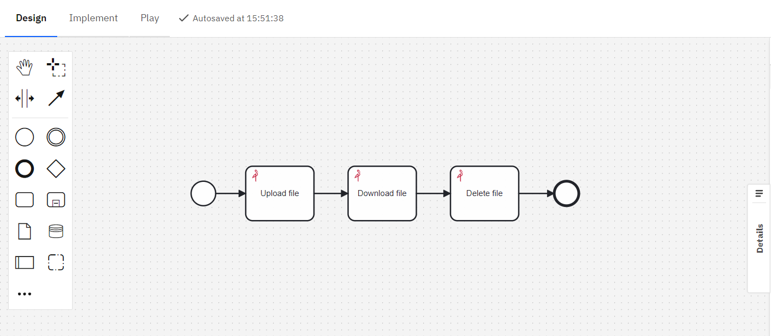  
Expanding Camunda Processes.

Integrate the capabilities of MinIO seamlessly into your Camunda processes through the MinIO Connector. Store, process and manage large amounts of data during process execution in a convenient and scalable form!

# **Features and Benefits** Upload file

Effortlessly transfer files to MinIO buckets straight from your Camunda processes, removing manual steps and speeding up your workflow.

Download file

Easily extract data directly into Camunda processes, eliminating delays and optimizing your workflow.Benefit from quick and reliable downloads, ensuring your file processes have all the necessary resources exactly when needed.

# Delete file Delete all unused files locally and in the MinIO buckets when you are done working with them. Keep your buckets clear.